5.4.3 Conic Sections (Hyperbolas)

If a plane passes through a double right circular cone there are four possible resulting curves. These curves are the parabola, circle, ellipse, and hyperbola. These curves are called conic sections and are shown below.
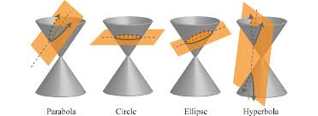

Definition: A hyperbola is the set of all points in a plane such that the difference between the distances from two fixed points (foci) is constant.
*Note the subtle difference between this definition and the definition for an ellipse which has the sums of differences from two fixed points as constant.*

The Equation of a Hyperbola: (opening left or right)
The equation of a hyperbola with center at the origin

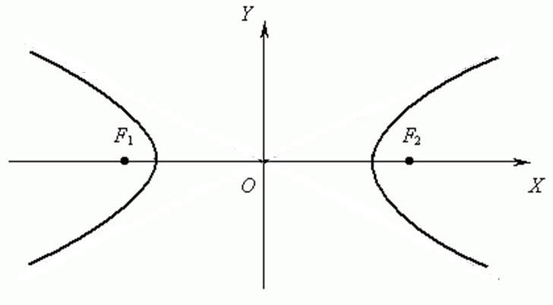

The Equation of a Hyperbola: (opening up or down)
The equation of a hyperbola with center at the origin

Note: With hyperbolas it is not important whether a or b is the larger value. We always think of a as the value beneath y and b as the value beneath x.

Graphing a Hyperbola

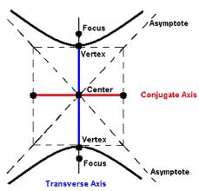
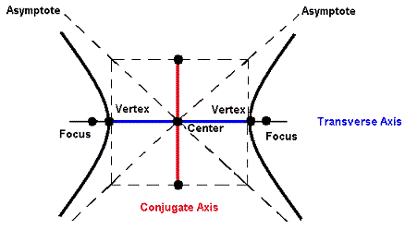
Example 1: Determine the foci, equations of the asymptotes, and sketch the graph of

Example 2: Determine the foci, equations of the asymptotes, and sketch the graph of

Example 3: Determine the foci, equations of the asymptotes, and sketch the graph of

Example 4: Find the equation of a hyperbola whose transverse axis had endpoints and whose conjugate axis has endpoints .

Example 5: Find the equation of the hyperbola with asymptotes and vertices .

Recapping Section 5.4

Example 6:
- Find an equation for the parabola with vertex , axis of symmetry , and which contains the point .
- Find the vertex/vertices of the conic determined by the equation .
- Find an equation of the ellipse with foci , and vertices , .

